AI ASSISTED CODING
Assisgnment-11.4
Rollno:2303a52146
Name: V. Praneeth reddy
Batch:41
Task 1:
Stack Implementation for Undo Operations (LIFO)
Prompt Used
Implement a Stack class in Python with push, pop, peek, and is_empty methods. Add proper docstrings, explain why Stack is suitable for undo functionality, and compare list-based and deque-based implementations.
Code
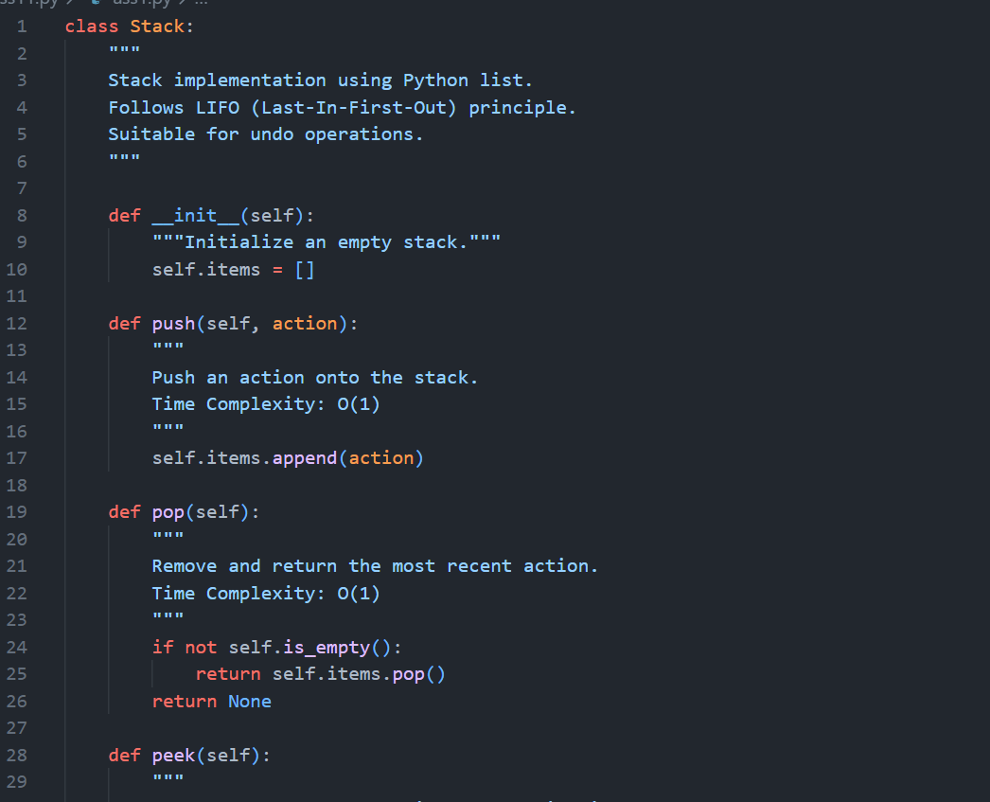
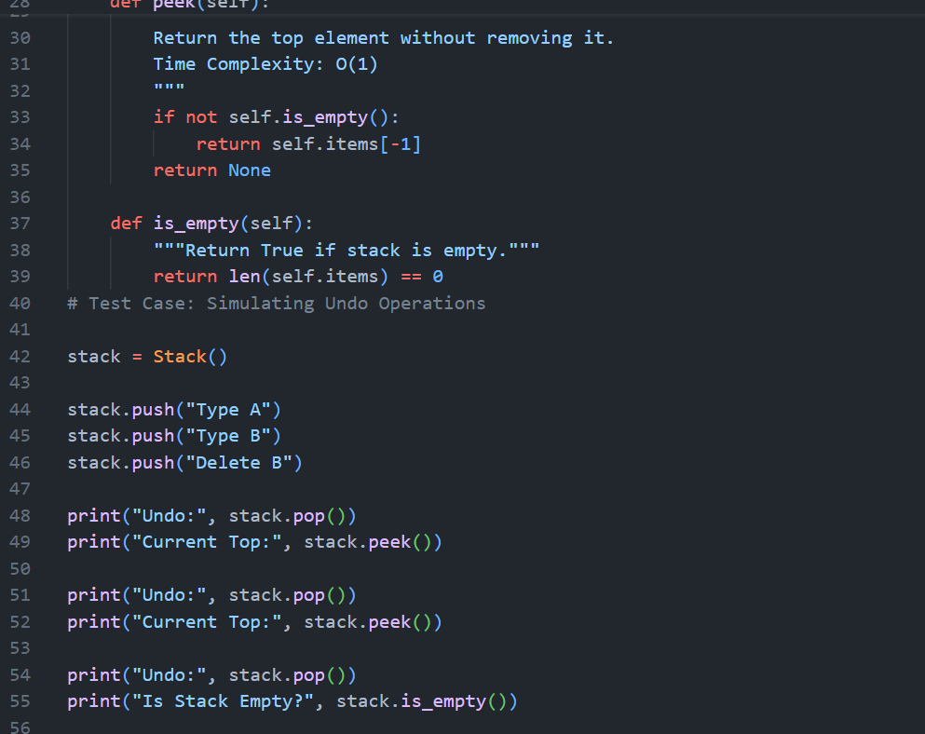
Output:
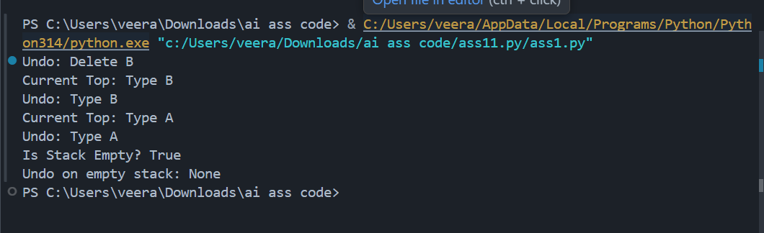

Justification
Why Stack is Suitable for Undo
Undo operations must reverse the most recent action first. This matches LIFO behavior:
- Latest action → undone first
- Earlier actions → undone later
Example:
- Type A
- Type B
- Delete B
Undo → Delete B undone first
Stack provides O(1) push and pop, making it ideal for frequent undo operations.
Task 2: Queue for Customer Service Requests (FIFO)
Prompt Used
Implement a Queue using list, analyze performance, and optimize using deque.
Code
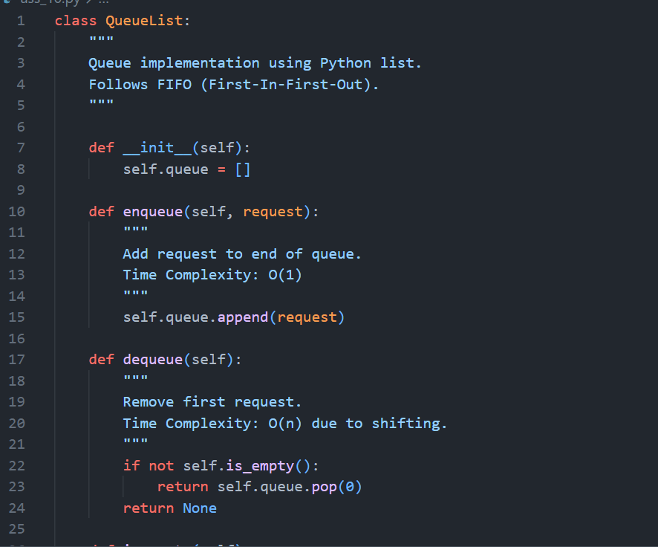
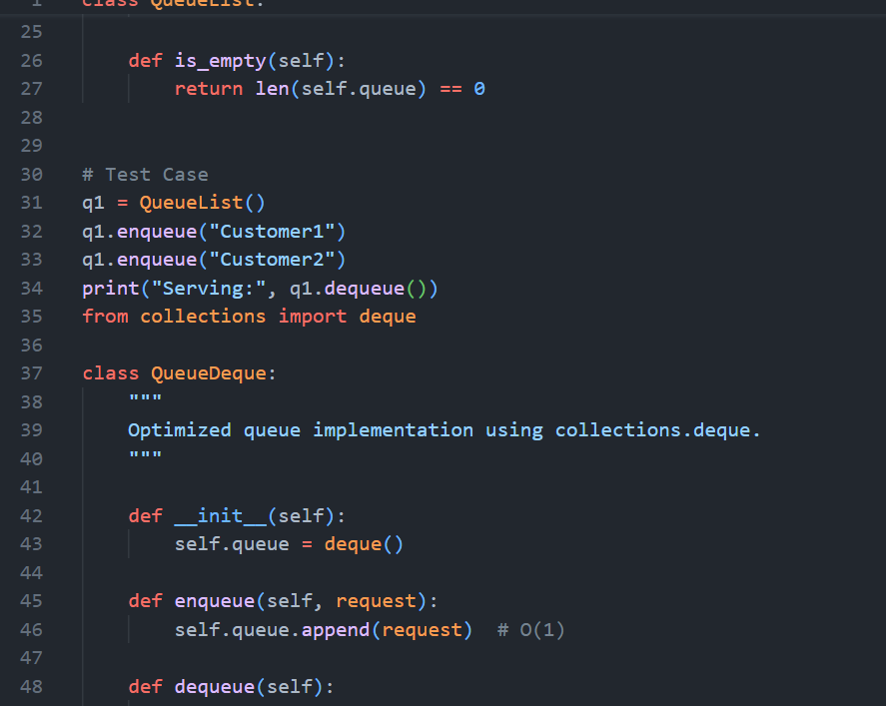
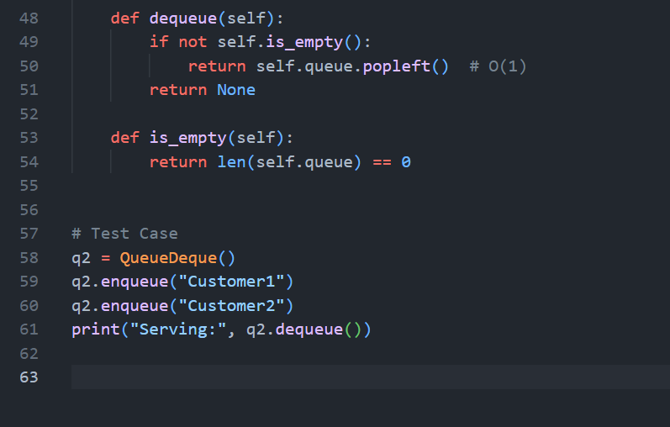
Ouput:
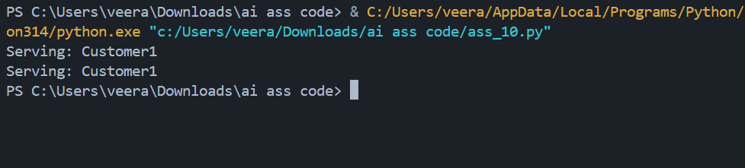
Performance Analysis
List-Based Queue
- enqueue → O(1)
- dequeue → O(n) (shifts elements)
For 10,000 requests, dequeue becomes expensive.
Deque-Based Queue
- enqueue → O(1)
- dequeue → O(1)
Deque uses a doubly-linked structure internally, avoiding element shifting.
Real-World Impact
In high-volume systems (banking, server queues, chat systems), list-based queues degrade performance significantly. Deque ensures stable O(1) operations.

Task 3: Singly Linked List for Dynamic Playlist Management
Scenario
You are designing a music playlist feature where songs can be added or
removed dynamically while maintaining order.
Task Description
• Implement a Singly Linked List with:
o insert_at_end(song)
o delete_value(song)
o traverse()
prompt used
Add inline comments explaining pointer manipulation, Highlight tricky parts of insertion and deletion,Suggest edge case test scenarios (empty list, single node,deletion at head)
Code
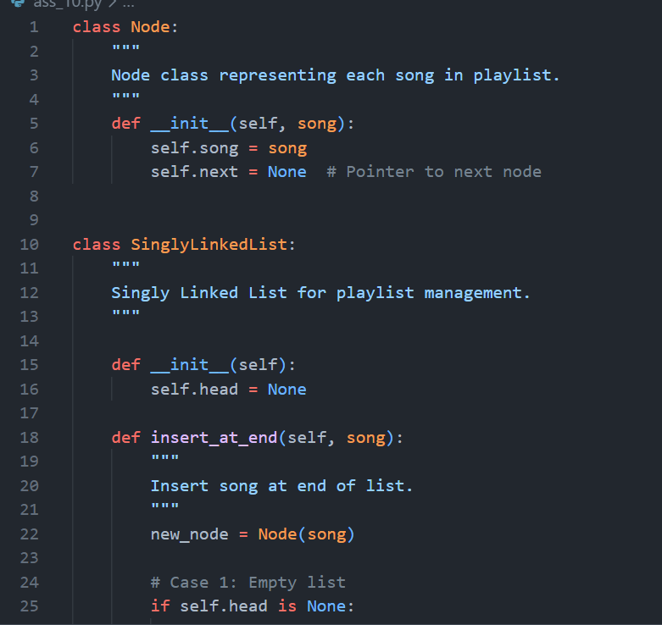
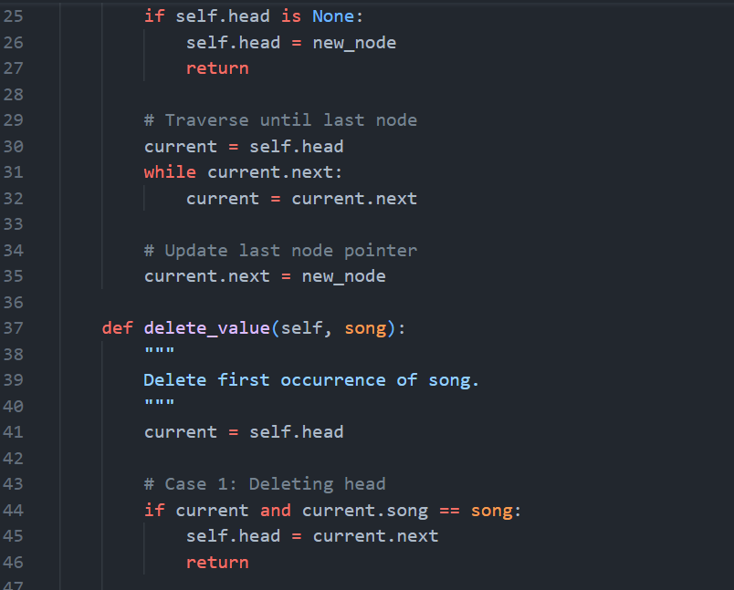
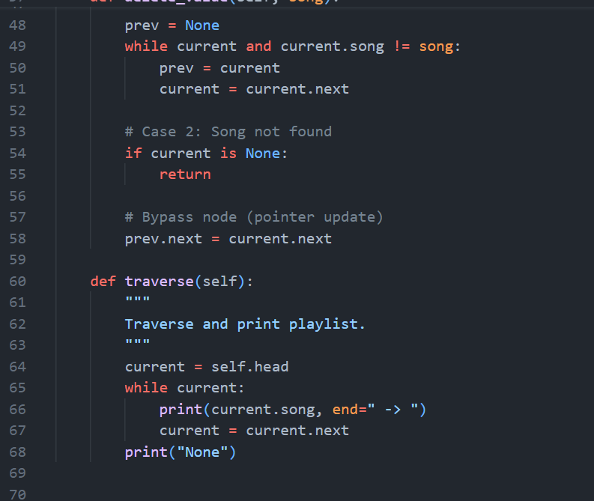
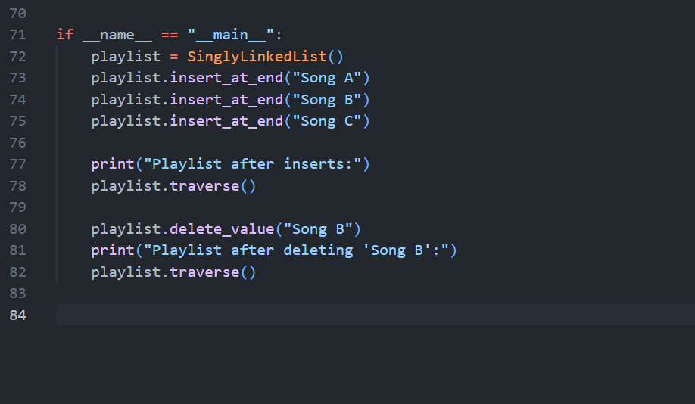
Output:
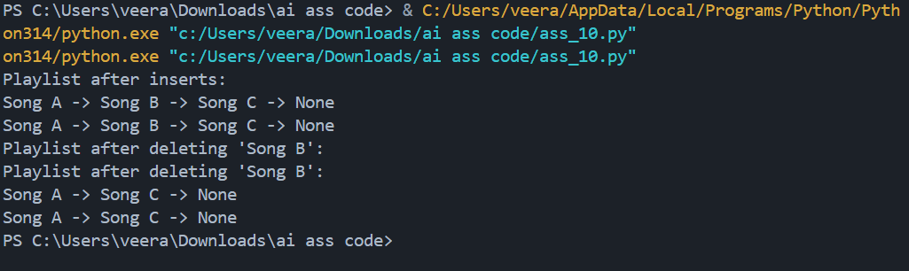
Task 4: Binary Search Tree for Fast Record Lookup
Scenario
You are building a student record system where quick searching by roll
number is required.
• Implement a Binary Search Tree (BST) with:
o insert(value)
o search(value)
o inorder_traversal()
• Provide AI with a partially written Node and BST class.
• Ask AI to:
o Complete missing methods
o Add meaningful docstrings
o Explain how BST improves search efficiency over linear search
Prompt used :
Complete missing methods,Add meaningful docstrings, Explain how BST improves search efficiency over linear search
Code:
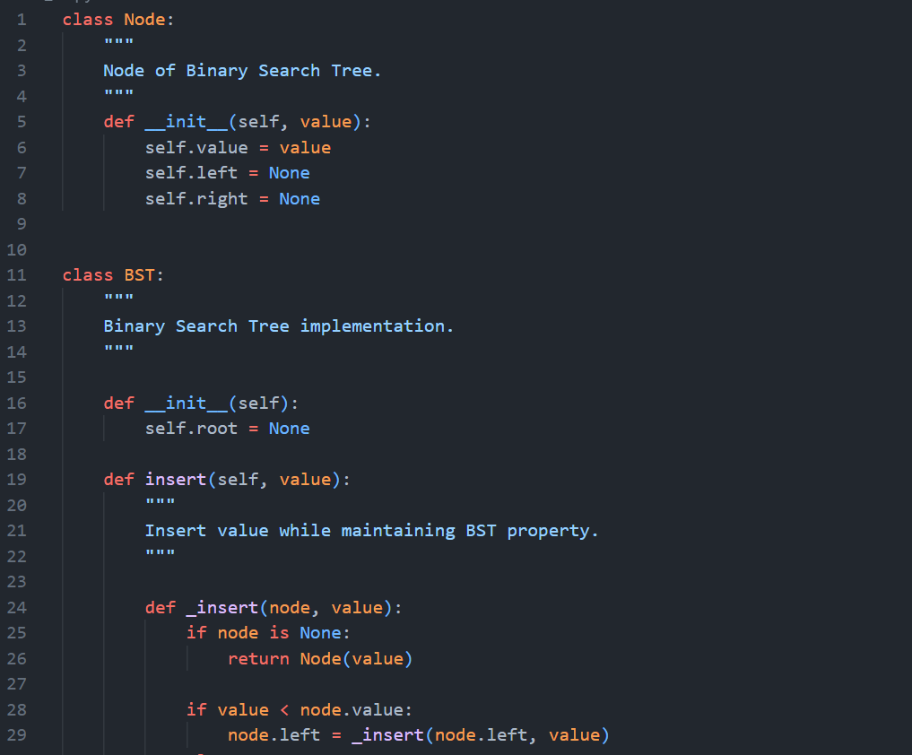
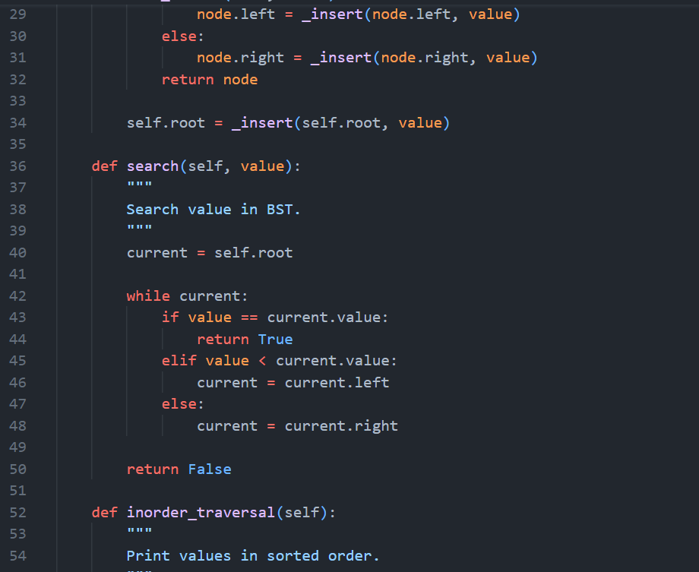
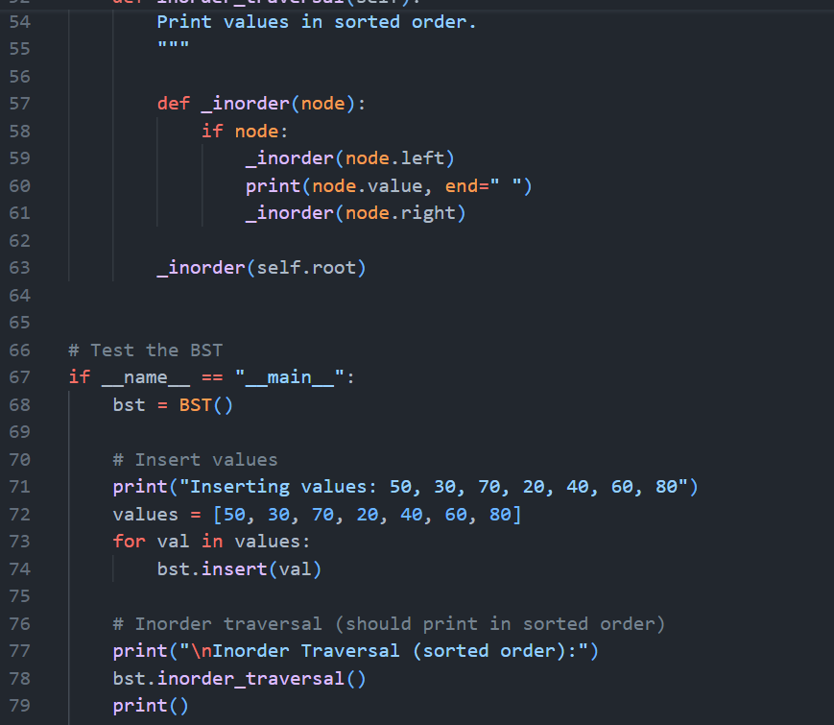
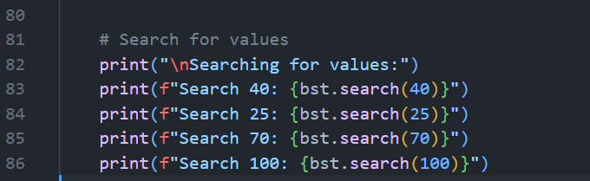
Output:
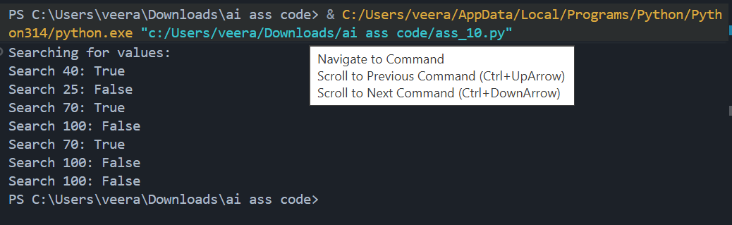
Why BST Improves Search Efficiency
Approach | Time Complexity
Linear Search | O(n)
BST (Average) | O(log n)
BST (Worst - Skewed) | O(n)
BST reduces search space by half at each step in balanced cases.
Task 5: Graph Traversal for Social Network Connections
Scenario
You are modeling a social network, where users are connected to friends, and
you want to explore connections.
Task Description
• Represent the network using a graph (adjacency list).
• Use AI to implement:
o Breadth-First Search (BFS) to find nearby connections
o Depth-First Search (DFS) to explore deep connection paths
prompt used:
Add inline comments explaining traversal steps, Compare recursive and iterative DFS approaches,Suggest practical use cases for BFS vs DFS
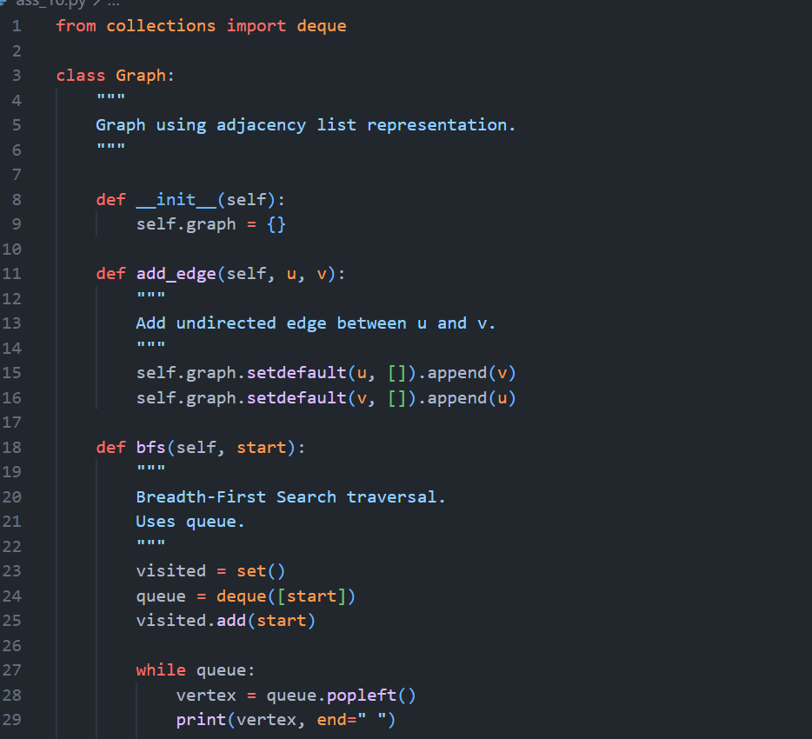
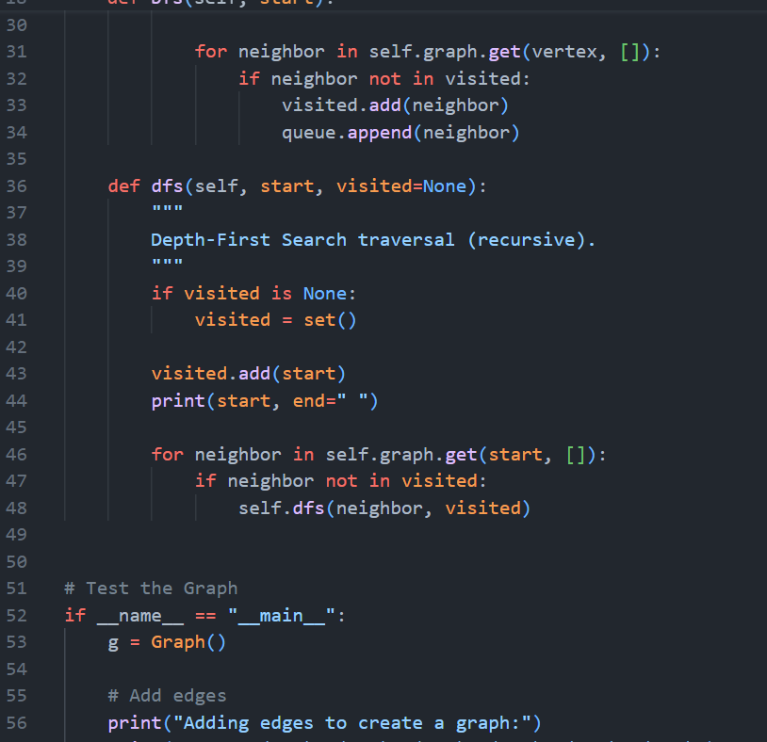
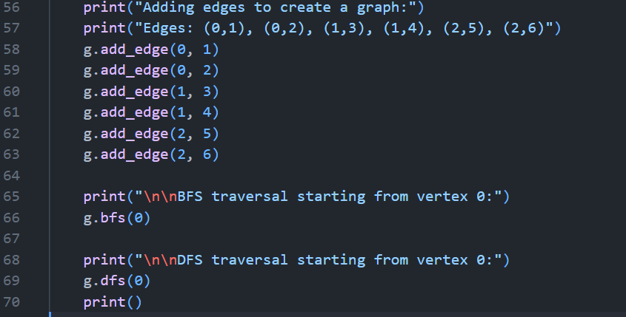
Output:
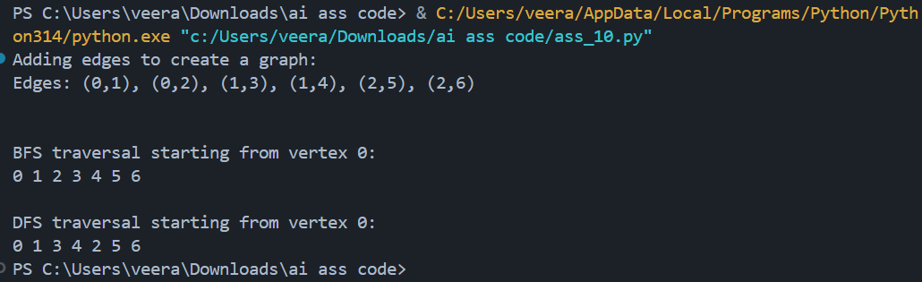

BFS vs DFS Comparison
Feature | BFS | DFS
Structure | Queue | Stack/Recursion
Traversal | Level-by-level | Depth-first
Shortest Path | Yes (unweighted) | No
Memory | Higher (wide graphs) | Lower (deep graphs)
Practical Use Cases
BFS:
- Shortest path
- Social network degree search
- Broadcasting systems
DFS:
- Cycle detection
- Path existence
- Topological

